Book of Revelation- Study Art 1.1
Bro. Andrew Johnson, 2019
DISCLAIMER:
Please feel free to use my work as a “jumping-off point,” but please be careful to NEVER use it to replace your own Biblical study or thought! Bible study is a wonderful, personal, and essential part of learning and growing in faith, and should never be sidelined or replaced by ANY artist’s rendering.
Intent:
To provide visuals fit for presentations or classes. This material was generated for a specific class at a gathering in 2019 that was dedicated to exploring the narrative construction of the Revelation, not the specific meaning of the symbols.
Important Notes:
These drawings represent my own suggestions of some of the core figures in Revelation 12, 13, and 17. The class for which I was designing the imagery was about the shared relationships and charteristics/ qualities of the systems that they may represent.
As a quick reference, my illustrations reflect the following:
A) The Great Red Dragon
Or, “Great, Fiery Serpent.” Revelation 20 refers to this dragon as “that old Serpent” (20:2), which is fitting since many East- Middle Eastern dragons, such as the constellation Draco, are typically depicted in folklore as serpentine. This tradition has been borne out in the East, long since John’s Apocalypse, through sculptures like those created of the 7-headed Naga for Angkor Wat (12th Century)
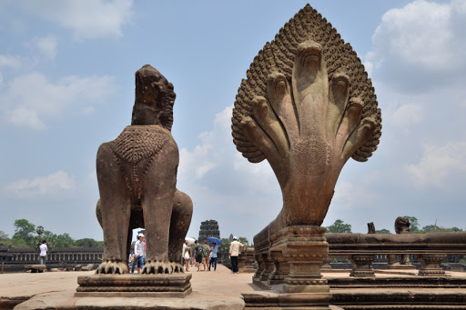
Figure 1 The 7-headed Naga demonstrates an Eastern view of the dragon
In keeping with the his information, I chose to make a large wingless serpent that emerges from the darkness of the stars and entangles itself within the midheaven of the earth. I also chose to make the heads of the dragon follow a sort of horizontal sequence rather than a sort of tangled, random spray of heads at the neck.
The idea of a sequence of heads may be correct. When Revelation 17:10 speaks about the heads of the Scarlet Beast, it says of the heads, “Five have fallen, one is, the other has not yet come,” which seems to indicate that the heads flow in some sort of order. This reminded me of animation classes I once took that talked about “keyframing” points of motion- in other words, separating motion into its most noticeable major components. Is this the sort of thing that John saw as he experienced his vision?
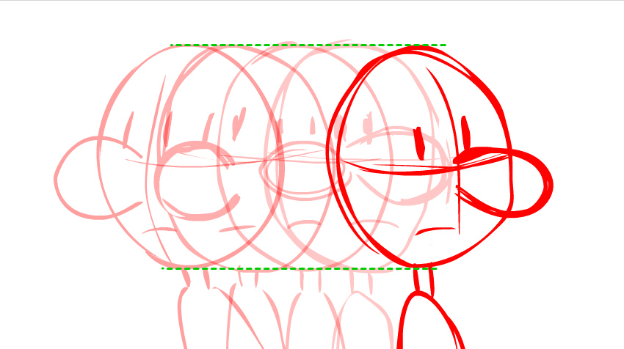
Figure 2 Changes in the motion of a figure over time are called "keyframes." Could the7 positions of the heads have had a similar look in John’s vision, demonstrating changes in the power of a single system over time?
B) Ten Horns, Seven Heads
With both the Dragon and the Beast of the Sea, there is some question as to how these horns are distributed? Given the number of heads, the horns could be arranged in the neat sequence: 1,2,1,2,1,2,1. I chose to do this in my drawings, but I’m not convinced that this is correct. It is entirely possible- if my above assumption about the “keyframes” of the heads is correct, that all of the horns only appear on the “active” head. The same may be true for the crowns on the heads or horns respectively? From what is described it’s unclear, but may be something to consider.
C) The Identity of the Scarlet Beast
The speaker for whom I created these illustrations had some questions about the identity of the Scarlet Beast in Revelation 17. Was this beast (as I grew up believing) the Beast from the Sea? Or might it have been the only other similar beast that was revealed to be scarlet in color- the Great Red Dragon? In order to explore these questions, I made up a two different illustrations to represent some possibilities. These illustrations should be taken in that spirit, and not as my private endorsement of one view over another, and certainly not as a desire to create confusion!
In either case, I’ve always assumed the scarlet beast is quite large, though I can’t back that up! It’s just my own aesthetic preference, and should be taken with a grain of salt.
D) The Woman Clothed with the Sun
What does this look like, visually? It’s difficult to envision, and I doubt I have the answer! How can someone be clothed with the sun? Does this mean something like “bathed in sunlight?” Does it mean the sun unfolds like a garment to cover the woman? Further, how is the moon under her feet? Is she standing on the moon, or appear to be hovering over it? What size is the moon in relation to the woman?
Another question involves the stars around the woman’s head. When the dragon sweeps a third of the stars out of the sky with its tail in Revelation 12, is he sweeping away the stars of heaven, or might he be (as the class using these illustrations asked) sweeping away a third of the stars around the head of the woman? Why or why not?
E) The Beast of the Earth
I probably took the most liberties with this illustration, since there is little in the way of a description. Of this creature, we only know that it has two horns like a lamb, but it speaks like a dragon. Further, we know that this creature can impart life to the image of the beast, and that it can do wonders, calling fire down from heaven.
I chose to make a sort of silhouetted beast that resembled a lamb, but, again, this is a huge assumption on my part, and should be taken with great skepticism.

Production Notes:
All of these illustrations were created over the course of a month and a half using digital media. Paintings were done in Photoshop. Some elements, such as the dragon’s heads, were fabricated n 3D Studio max to create a uniform model, then painted over later.

